Find the volume of the region bounded by the curve $y=\sqrt{x}$ and the line $x=4$
revolved about the y-axis.
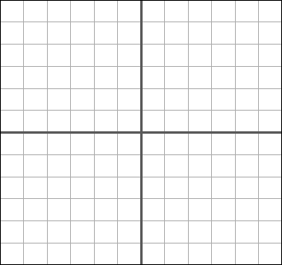

Washer Method

Circle one: dx dy Limits: _____ to _____

R = ________________ r = ________________

Setup integral:

Volume = __________

Shell Method

Circle one: dx dy Limits: _____ to _____

R = ________________ h = ________________

Setup integral:

Volume = __________

